Entity Framework 6.

1. In Project, add sqlite from nuget packages

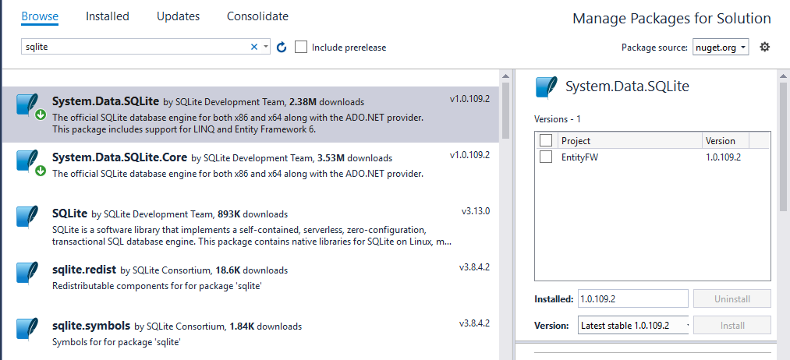

1. Download Sqlite windows binary distributable

<https://system.data.sqlite.org/index.html/doc/trunk/www/downloads.wiki>

Note install that package having(**This is the only setup package that is capable of installing the design-time components for Visual Studio 2015. )**

1. Download and install latest tool box

<https://github.com/ErikEJ/SqlCeToolbox/wiki/EF6-workflow-with-SQLite-DDEX-provider>

1. Database first approach – Using designer

In Blank Project, below it the configuration file generated after adding sqlite from nuget.



Add New >Ado.net Entry Data Model

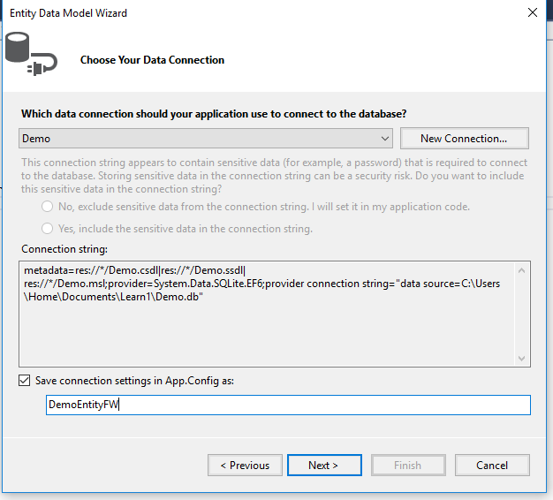

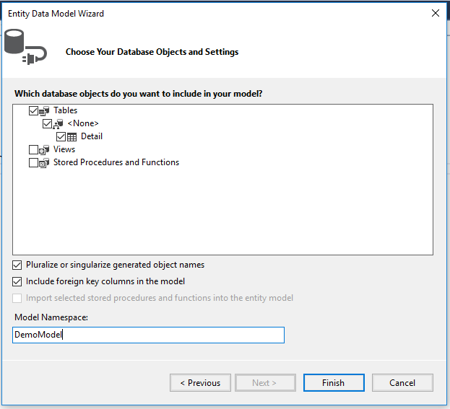

Solution looks like

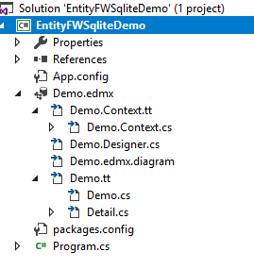

App.config after designer



We get this error after executing.

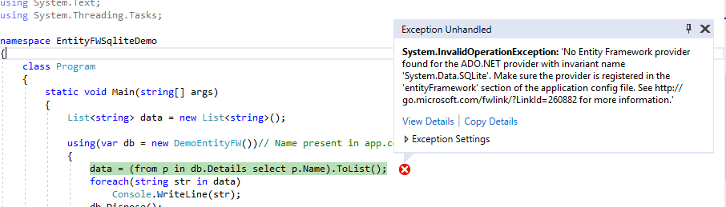

To resolve, add below entry in providers.

<provider invariantName="System.Data.SQLite" type="System.Data.SQLite.EF6.SQLiteProviderServices, System.Data.SQLite.EF6" />



1. Database first approach – without designer

Add the model class eg Detail (Same name as DB table)

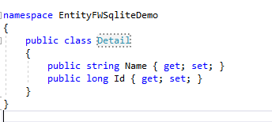

Add the Context Class

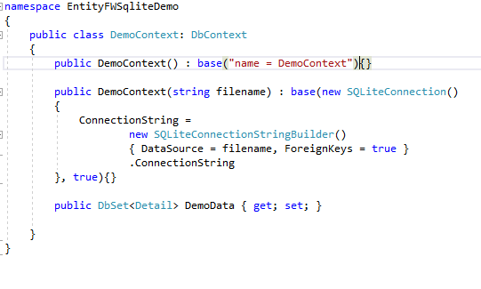

App.config



When running with these setting getting below error

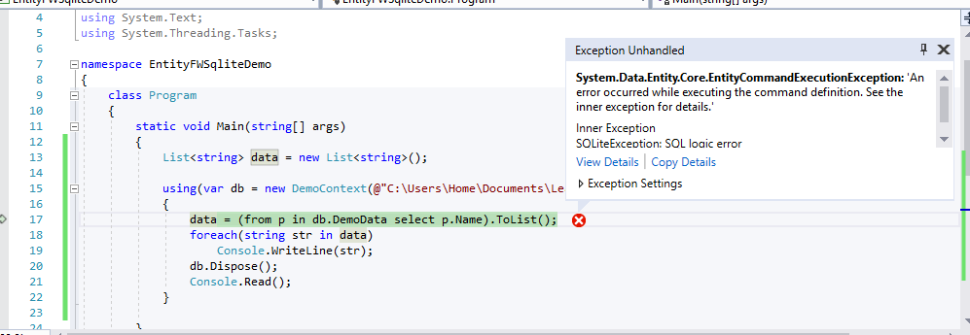

To Resolve , Add below function in DemoContext

protected override void OnModelCreating(DbModelBuilder modelBuilder)

{

modelBuilder.Conventions.Remove<PluralizingTableNameConvention>();

base.OnModelCreating(modelBuilder);

}

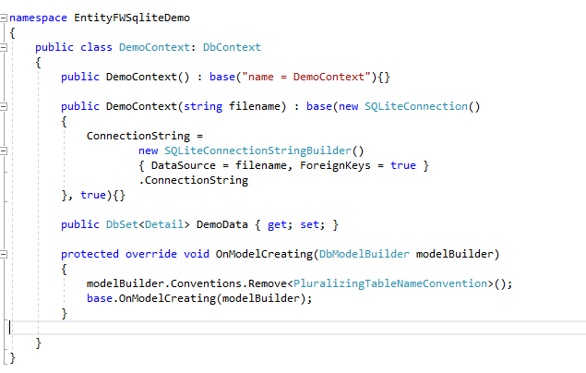

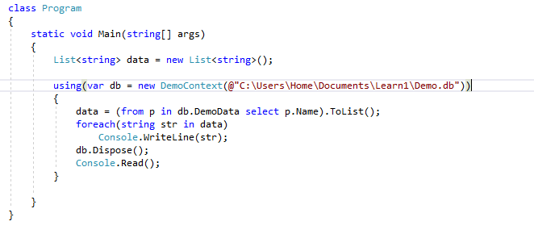

To run with checking config from app.config, add connection string



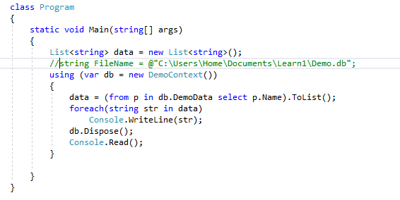

To Run by adding configuration using code, change App config like below

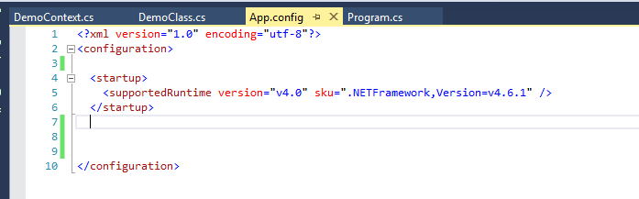



Add a File SQLiteConfiguration

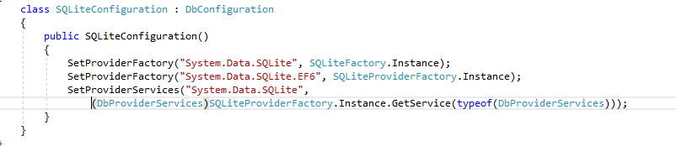

Now it will run

To Add configuration in app config for configuration string, and provider in code, will also work.



